Secure File Storage System

Technical Report
Course: Data Security Final Project
Project Type: Hybrid Encryption File Storage System
Technologies Used: Python, RSA, AES, Base64 Encoding

Prepared By
- Jomana Khaled 211005833
- Shahd Mohamed 211007942
- Mohamed Ahmed Abdelaziz 211005916
- Abdelrahman Mesbah 211006306

Public Project Links
GitHub Repository:
[Insert Public GitHub Repository Link Here]
Google Drive Demo Video:
[Insert Public Google Drive Demo Video Link Here]

1. Project Overview
The Secure File Storage System is a cryptographic application aimed at providing a way to securely store and transfer files through a hybrid encryption method. It is based on combining RSA and AES encryptions in order to ensure confidentiality, safe key exchange, and secure file encryption.

The application enables users to:

• Create RSA public and private keys
• Encrypt files securely
• Decrypt encrypted files
• Safely store encrypted files
• Exchange encrypted files with other users

The project was developed using Python and consisted of modules for encryption, encoding, storing, and interfacing with users.

2. Algorithms Used
The project uses the following algorithms and techniques:
Algorithm | Purpose
RSA | Encrypting the AES session key
AES-128-CBC | Encrypting the actual file data
Base64 Encoding | Safe storage and transmission of encrypted binary data
UTF-8 Encoding | Converting plaintext strings into bytes
Random Key Generation | Creating secure AES session keys and IVs

3. RSA Implementation Explanation

RSA is an asymmetric encryption scheme that utilizes:

• Public Key Encryption

• Private Key Decryption

The functions of the RSA module are as follows:

1. Generation of Prime Numbers

2. Calculation of Modulus

3. Public/Private Key Generation

4. Encryption/Decryption of Text

RSA Workflow

1. Choose two distinct prime numbers p and q.

2. Compute:

n = p * q

3. Calculate Euler’s Totient Function:

φ(n) = (p – 1) * (q – 1)

4. Choose the value of public exponent ‘e’.

5. Compute the value of private exponent ‘d ’.

6. Public key = (e, n)

7. Private key = (d, n)

RSA Encryption Formula


Where:
M – Plaintext/Message
C – Ciphertext
e – Public Exponent
n – Modulus
The encryption process requires the use of a public key (e,n).

RSA Decryption Formula
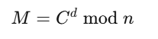
Where:
C – Ciphertext
M – Plaintext/Message
d – Private Exponent
n – Modulus
Decryption requires the use of the private key (d,n).

Why We Used RSA
RSA is used because it allows secure exchange of the AES session key without sharing secret information directly.

4. AES Implementation Explanation

AES stands for Advanced Encryption Standard, which is a cryptographic algorithm that enables efficient encryption of bulk data through symmetric encryption.

Used techniques include:

• AES-128

• CBC (Cipher Block Chaining) mode

• Random Initialization Vector (IV)

AES Encryption Steps

1. Generation of random AES-128 key.

2. Generation of random IV.

3. Splitting the file into blocks of data.

4. Encryption of each block using AES-CBC algorithm.

5. Obtaining ciphertext.

AES Formula
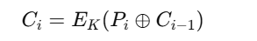
Where:
- Pi = plaintext block
- Ci = ciphertext block
- K = encryption key
- C(i-1) = previous ciphertext block

Why AES Was Used
AES is extremely fast and suitable for encrypting large files efficiently.

5. Hybrid Encryption Workflow

The system uses both RSA and AES in combination.

Hybrid Encryption Process
- User chooses the file to use.
- System creates a random AES session key.
- File encryption by AES
- AES session key encryption by RSA public key
- Both the encrypted file and the encrypted key are saved together.
- In the decryption procedure:
  - Use the RSA private key to decrypt the AES session key
  - Use AES key to decrypt the file

Advantages of Hybrid Encryption
- Quicker than RSA only method
- More secure than AES only method
- Convenient to use for large files
- Secure key exchange

6. Encoding Scheme Explanation
The project uses two encoding schemes:

UTF-8 Encoding
Used for:
- Human-readable plaintext
- User input text
UTF-8 converts strings into bytes before encryption.
Example:
"Hello" → Binary UTF-8 bytes

Base64 Encoding
Used for:
- Ciphertext
- IV values
- Encrypted session keys
Base64 converts binary encrypted data into ASCII-safe text.

Why Base64 Was Needed
Encrypted data contains unreadable binary bytes. Base64 allows:
- Safe JSON storage
- Safe file transfer
- Easy display in the UI

7. Key Generation Process

RSA Key Generation
The system automatically generates:
- Public key
- Private key

Steps
- Generate prime numbers
- Calculate modulus n
- Calculate φ(n)
- Generate public exponent e
- Calculate private exponent d

AES Session Key Generation
The AES key is generated using:
- os.urandom(16)
This produces:
- 16 random bytes
- 128-bit AES key
Each encrypted file gets a unique AES key.

8. System Architecture / Workflow

Main Modules
Module | Responsibility
rsa.py | RSA encryption/decryption and key generation
aes.py | AES encryption/decryption
hybrid.py | Hybrid encryption workflow
encoding.py | UTF-8 and Base64 conversion
storage.py | File saving/loading
main.py | User interface and system control

Workflow Diagram
User → Select File → AES Encrypt File → RSA Encrypt AES Key → Save Encrypted Package
For decryption:
User → Load Encrypted File → RSA Decrypt AES Key → AES Decrypt File → Restore Original File

9. User Interface Screenshots

Screenshot 1 – Main Menu
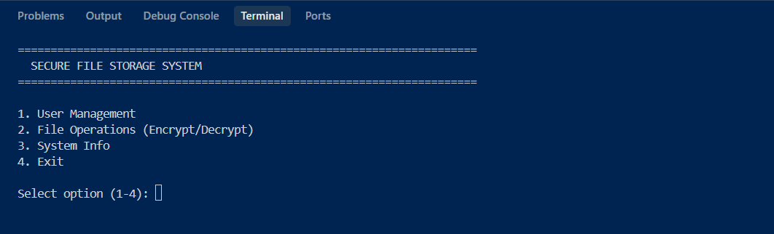

Screenshot 2 – File Operations

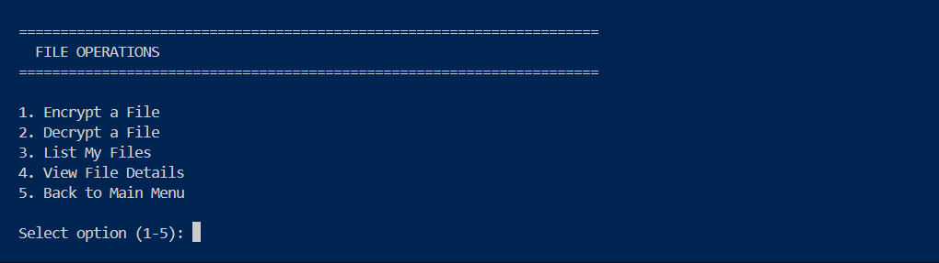

Screenshot 3 – File Encryption Process

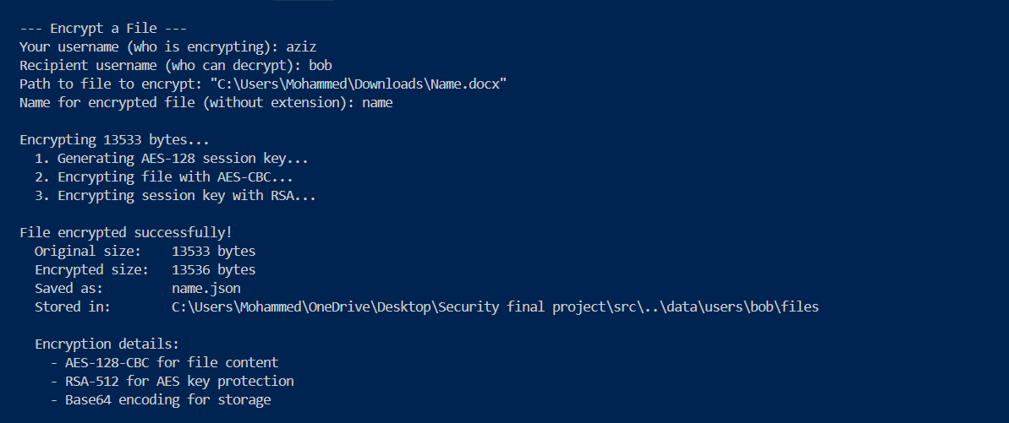

Screenshot 4 – File Decryption Process

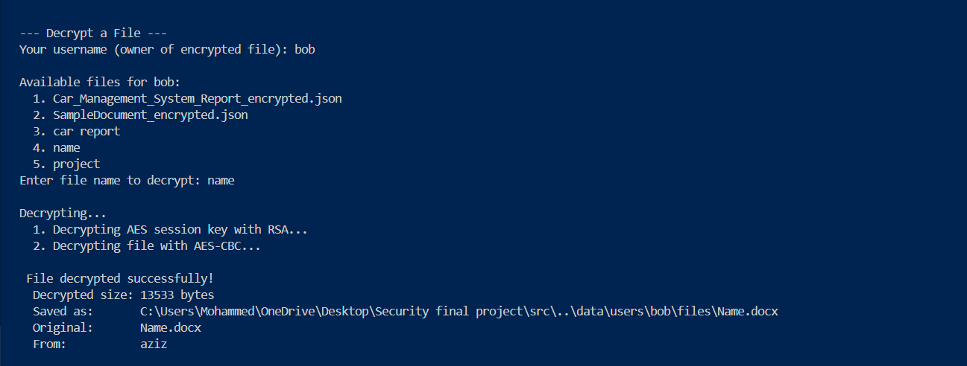

Screenshot 5 – Stored Encrypted Files

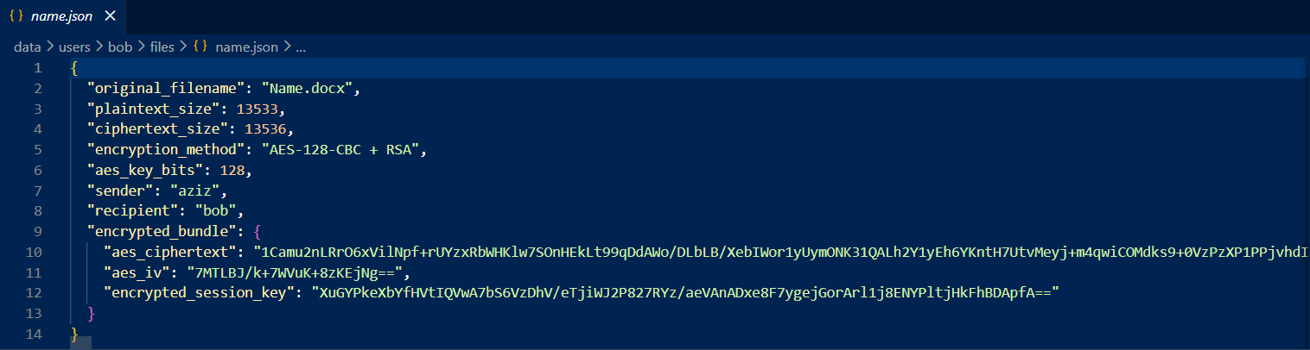

Screenshot 6 – User Management (Register New User)

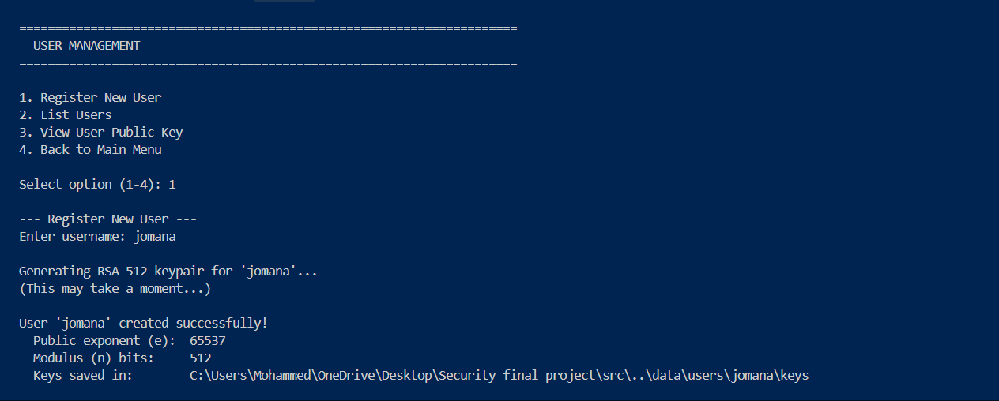

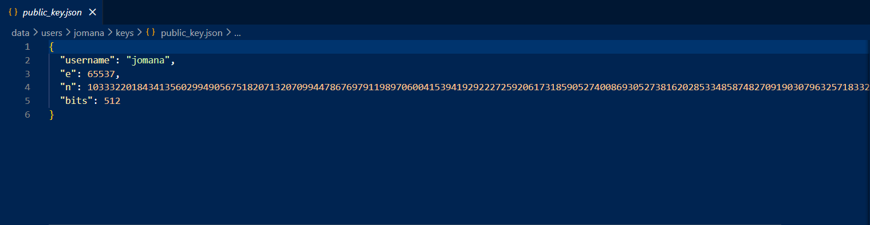
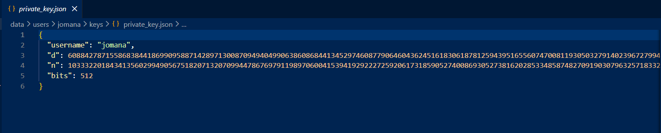
Screenshot 7 – Generated Keys

10. Business Model Explanation
The Secure File Storage System can be used in:
- Cloud storage services
- Secure enterprise systems
- Government systems
- Banking applications
- Medical record protection
- Secure communication systems

Potential Customers
- Companies storing confidential files
- Universities protecting student records
- Organizations requiring secure data transfer

Value Provided
- Data confidentiality
- Secure file sharing
- Protection against unauthorized access
- Secure storage of sensitive information

11. Optimizations and Simplifications

Optimizations
  - AES used for data encryption due to its speed.
  - RSA is only used to encrypt the AES key, not the entire file.
  - Use of Base64 encoding makes storage easy.
  - The modular nature makes maintenance easier.

Simplifications
  - Only AES-128 is implemented instead of AES-256.
  - Files are used for data storage rather than using a database.
  - Use of a console rather than graphical user interface.
  - Key is stored locally for ease of testing.

12. Team Member Contributions

Member 1: RSA, AES & Main Application
- Implemented RSA encryption and key generation
- Implemented AES encryption/decryption
- Managed CBC mode and IV handling
- Built command-line interface with menus
- Created system information display

Member 2: Hybrid Model
- Implemented hybrid encryption workflow
- Connected the RSA and AES modules together
- Created file manifest and serialization system

Member 3: Storage
- Implemented user account management
- Managed encrypted file storage and retrieval
- Handled key pair persistence

Member 4: Encoding
- Implemented UTF-8 encoding for plaintext
- Implemented Base64 encoding for binary data
- Provided hex encoding utilities for debugging

13. References
- Omparghale, “aes-rsa-hybrid” — hybrid AES+RSA educational implementation. GitHub repository. https://github.com/omparghale/aes-rsa-hybrid (Used as a reference implementation for learning AES and RSA internals.)

- National Institute of Standards and Technology, “FIPS PUB 197: Advanced Encryption Standard(AES),”Nov.2001. https://nvlpubs.nist.gov/nistpubs/FIPS/NIST.FIPS.197.pdf
(Official AES specification.)

- National Institute of Standards and Technology, “SP 800 38A: Recommendation for Block Cipher Modes of Operation, ”Dec.2001. https://nvlpubs.nist.gov/nistpubs/Legacy/SP/nistspecialpublication800-38a.pdf (CBC mode examples and test vectors.)

- RSA Laboratories, Rivest, Shamir & Adleman, “A Method for Obtaining Digital Signatures and Public Key Cryptosystems,” Communications of the ACM, vol. 21, no. 2, 1978. https://people.csail.mit.edu/rivest/Rsapaper.pdf — (Original RSA paper.)

14. Conclusion
The Secure File Storage System is a successful demonstration of hybrid cryptography that effectively encrypts, stores, and decrypts data files through the use of RSA and AES algorithms.
Moreover, the following cybersecurity concepts are being demonstrated through the project:
  - Symmetric Cryptography
  - Asymmetric Cryptography
  - Encrypted Key Exchange
  - Encoding
  - Secure File Storage
Future developments may include:
  - Cloud Integration
  - Database
  - GUI
  - Digital Signatures
  - Multi-User Authentication

